Cardiff Met Graduate Software Developer application

**Database:**

Assumptions:

1-course names are unique.

2-a module can be in more than one course; it will have the same name but it will have a different module_id for each course it belongs to.

3-No need to view a student’s older courses if he is a former student (only need to store his current enrolled course)

ERD:

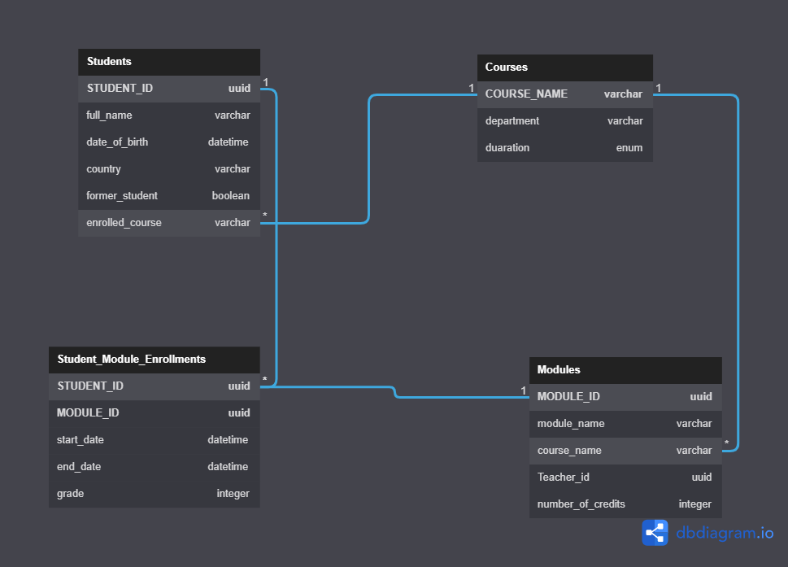

MYSQL code:

CREATE TABLE `Students` (

`STUDENT_ID` BINARY(16) PRIMARY KEY,

`full_name` varchar(255),

`date_of_birth` datetime,

`country` varchar(255),

`former_student` boolean,

`enrolled_course` varchar(255)

);

CREATE TABLE `Courses` (

`COURSE_NAME` varchar(255) PRIMARY KEY,

`department` varchar(255),

`duaration` enum('3','4','5')

);

CREATE TABLE `Modules` (

`MODULE_ID` BINARY(16) PRIMARY KEY,

`module_name` varchar(255),

`course_name` varchar(255),

`Teacher_id` BINARY(16),

`number_of_credits` integer

);

CREATE TABLE `Student_Module_Enrollments` (

`STUDENT_ID` BINARY(16),

`MODULE_ID` BINARY(16),

`start_date` datetime,

`end_date` datetime,

`grade` integer,

PRIMARY KEY (`STUDENT_ID`, `MODULE_ID`)

);

ALTER TABLE `Students` ADD FOREIGN KEY (`enrolled_course`) REFERENCES `Courses` (`COURSE_NAME`);

ALTER TABLE `Modules` ADD FOREIGN KEY (`course_name`) REFERENCES `Courses` (`COURSE_NAME`);

ALTER TABLE `Student_Module_Enrollments` ADD FOREIGN KEY (`STUDENT_ID`) REFERENCES `Students` (`STUDENT_ID`);

ALTER TABLE `Student_Module_Enrollments` ADD FOREIGN KEY (`STUDENT_ID`) REFERENCES `Modules` (`MODULE_ID`);

**Front End:**

**Live link:**

**Github link:**

**Code:**

**1)**

public static void solution(int [] arr) {

int score=0;

for(int i=0; i<arr.length; i++) {

if(arr[i]==7) {

score+=5;

break;

}

if(arr[i]==13) {

score-=5;

break;

}

if(arr[i]%2==0) {

score+=2;

}else {

score+=1;

}

}

System.*out*.println(score);

}

}

**2)**

Google Drive link: <https://drive.google.com/file/d/1iYmC-IqJHUgIGSfqAG0wVJUFxqX1s1fA/view>

}

}